**CP Club 365 Days Challenge**

**Programming language – C++**

**Problem Statement**

<https://www.codechef.com/problems/WAITTIME>

**Your Code**:

// 0x92Day of 0x365Days challenge

// VEDANT BHARAD

// 17-1-2023

#include <iostream>

using namespace std;

int main() {

    // your code goes here

    int t;

    cin>>t;

    while(t--){

        int k,x;

        cin>>k>>x;

        cout<<(7*k)-x<<endl;

    }

    return 0;

}

**Output (Screen Shot)**:

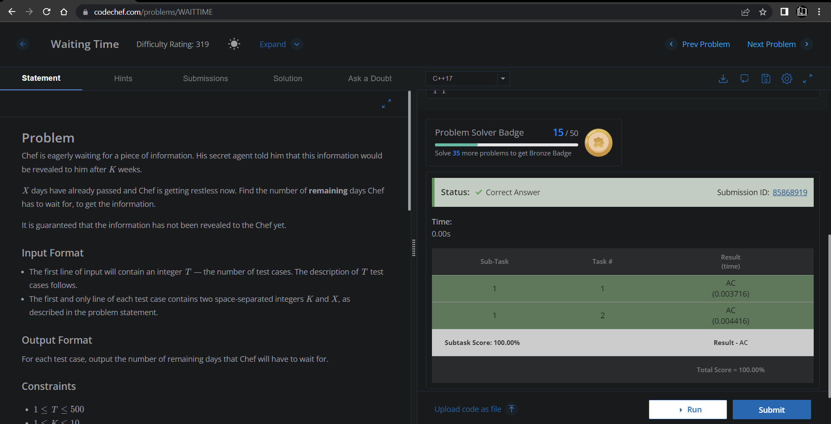

**Understanding about problem:**

* In this task I need to return remaining days form K weeks and passed X days,for that return (7*K) which are total days and then subtract passed days which are X.

Note: If you can't understand the problem, feel free to contact us and we'll help you. Please don't copy and paste from anywhere.

ALL THE BEST

Team CP Club